**Add end date in assignments of Offboarding Workflow**

**Solution 1**

1. **If user has a end date**

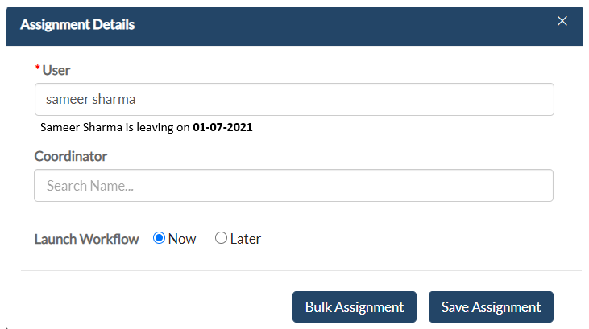

1. **If user don’t have any end date (remains same)**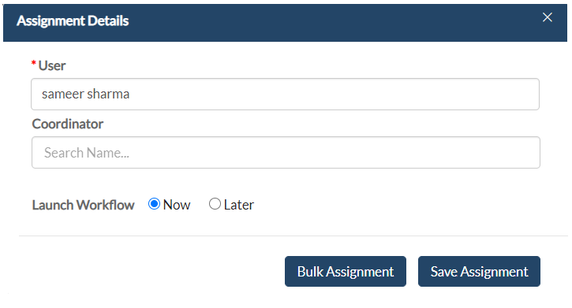

**Solution 2**

1. **Initially the box will look like below**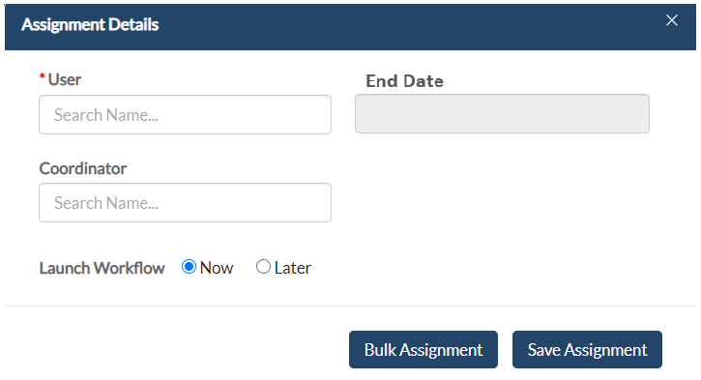

**NOTE: -** The end date column will be greyed out (unable to use) until the **User** is selected.

1. **After adding user**
2. **If user’s end date is already saved**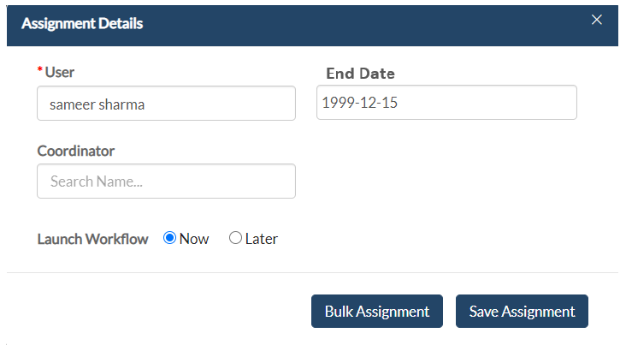
3. **If user’s end date is not already saved**